**Consider the below two tables**: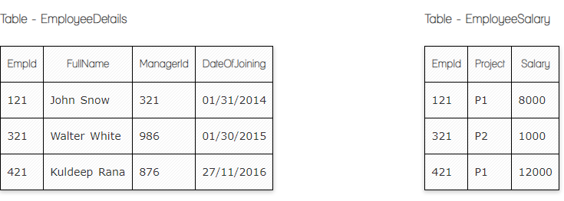

**Ques.1. Write a SQL query to fetch the count of employees working in project 'P1'.**

**My Answer:**

**SELECT count(*) FROM SMS.EmployeeSalary**

**where EmployeeSalary.project='P2';**

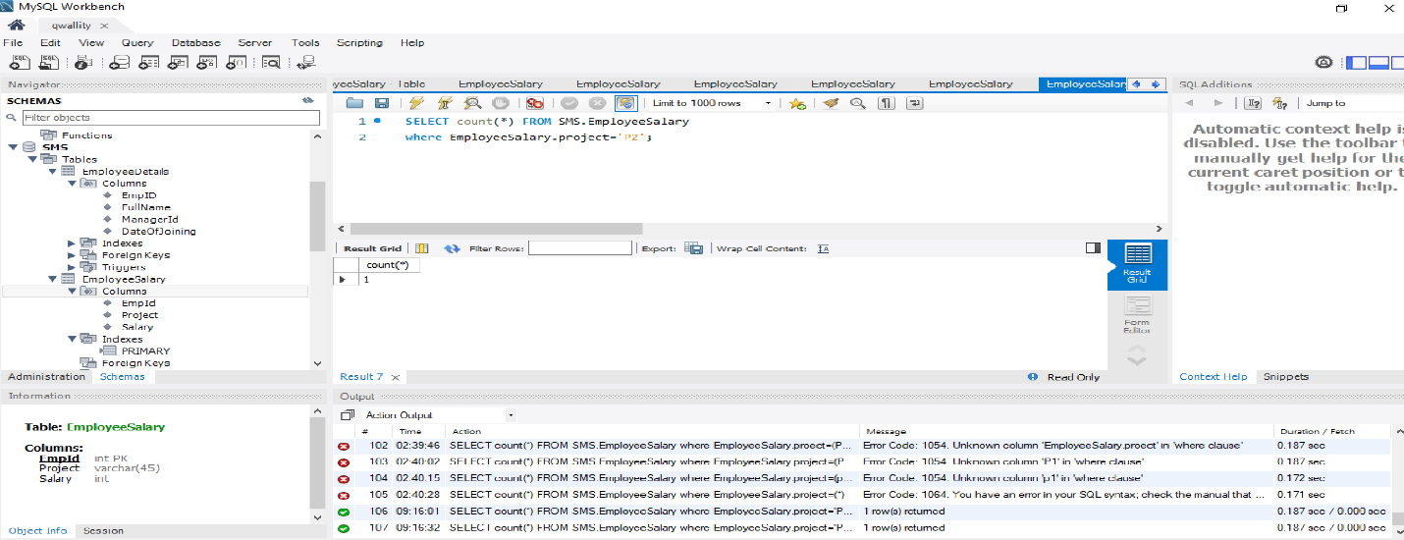

**Ques.2. Write a SQL query to fetch employee names having salary greater than or equal to 5000 and less than or equal 10000.**

**Answer:**

**1.select FullName**

**2.from EmployeeDetails**

**3. Inner Join EmployeeSalary**

**4. on EmployeeDetails.EmpID= EmployeeSalary.EmpId**

**5.where Salary between ‘5000’ And ‘10000’**

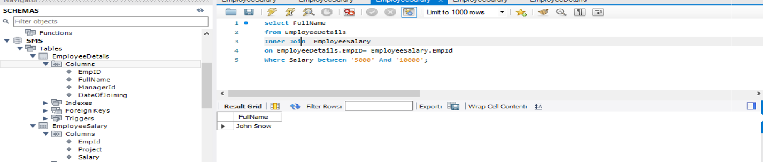

**Ques.3. Write a SQL query to fetch count of employees sorted by project's count in descending order.**

1. SELECT COUNT(Project), COUNT(EmpId)
2. FROM EmployeeSalary
3. GROUP BY Project
4. ORDER BY COUNT(Project) DESC;

**Answer:**

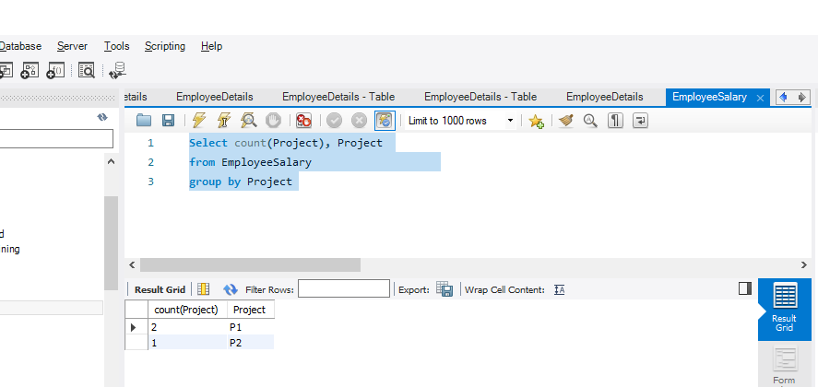

**Ques.4. Write a query to fetch employee names and salary records. Return employee details even if the salary record is not present for the employee.**

**Answer:**

**1.select fullName, Salary**

**2.from EmployeeDetails**

**3.inner join EmployeeSalary**

**4.on EmployeeDetails.EmpID= EmployeeSalary.EmpId**

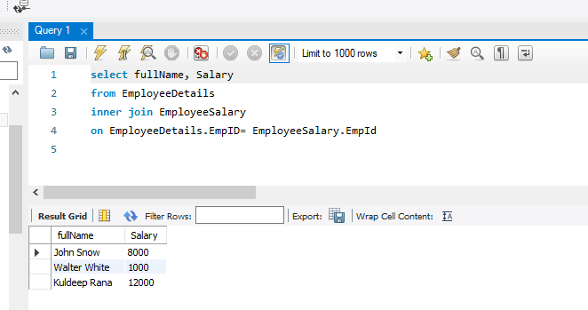

**Ques.5. Write a SQL query to create an empty table with ‘Test’ name.**

**Answer:**

**CREATE TABLE `SMS`.`test` (**

**);**

**Ques.6. Write a SQL query to delete an empty table with ‘Test’ name.**

**Answer:**

**DROP TABLE ‘test’**

**Ques.7. Write a SQL query to fetch all the Employees details from EmployeeDetails table who joined in Year 2016.**

**Answer:**

1. **select \***
2. **From EmployeeDetails**
3. **where DateOfJoining like '2016%'**

**Ques.8. Write a SQL query to insert new record to the EmployeeDetails table with any data.**

**Answer:**

**INSERT INTO `EmployeeDetails` (`EmpID`, `FullName`, `ManagerId`, `DateOfJoining`) VALUES ('536', 'Sus Mark', '575', '12/05/2012');**

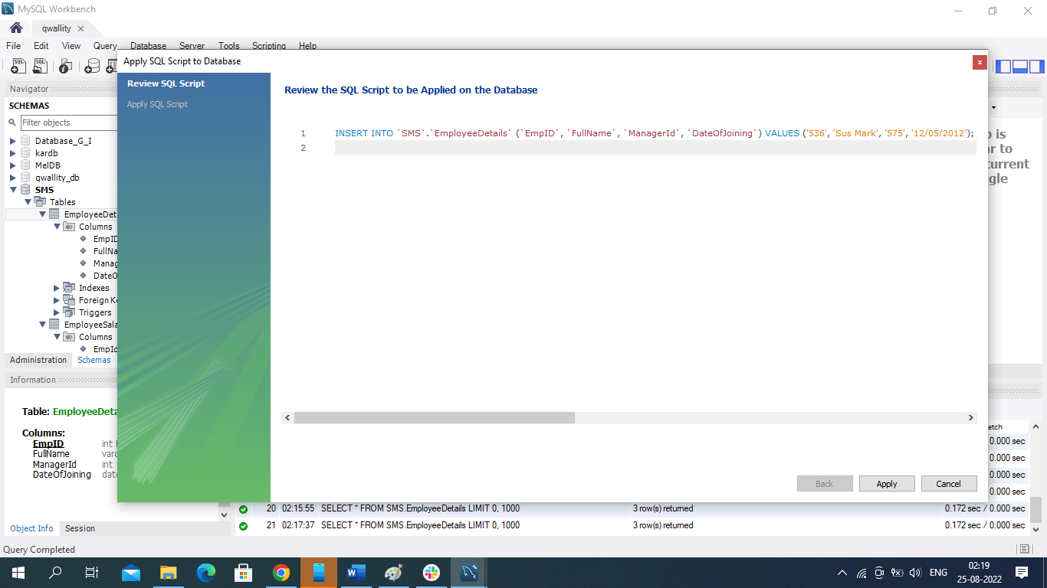

**Ques.9. Write a SQL query to update EmployeeSalery table with setting Salary to 2000 for Project P2.**

**Answer:**

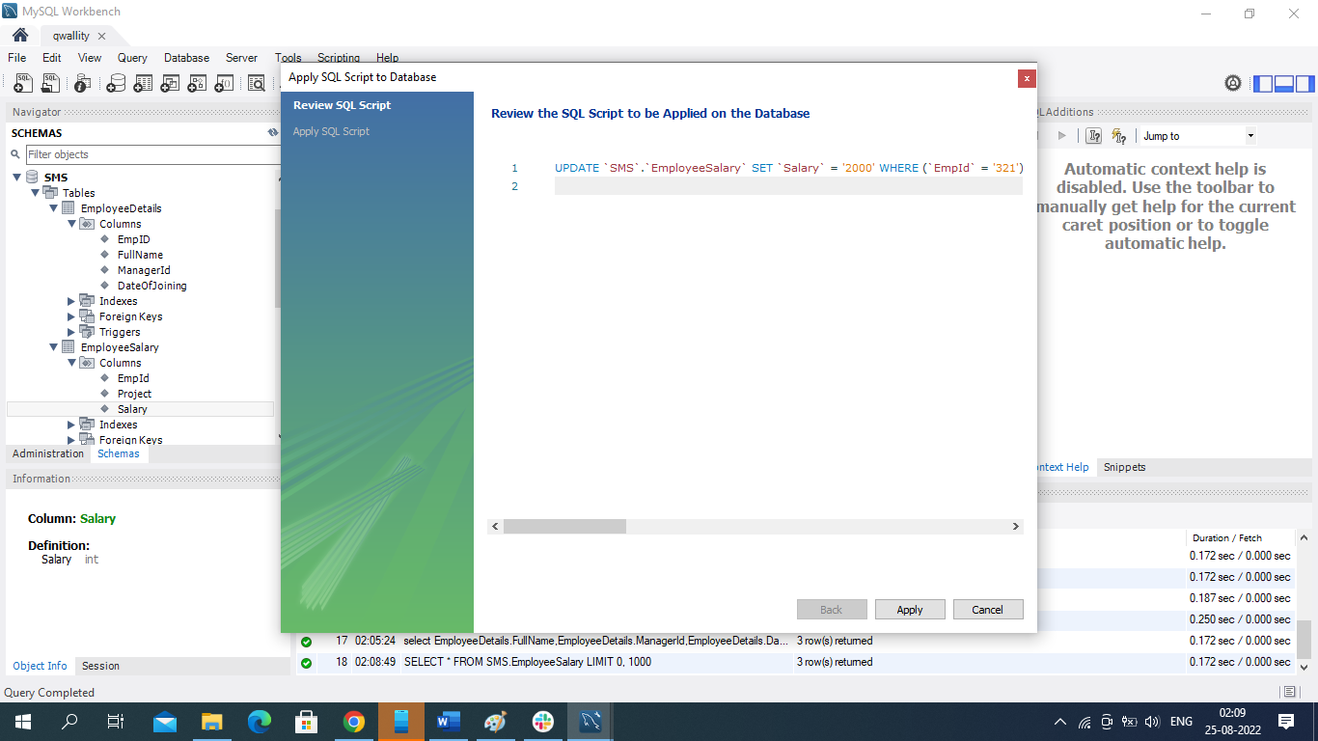

**Ques.10. Write a SQL query to right join both tables and draw the results.**

**Answer:**

**Select EmployeeDetails.FullName, EmployeeDetails.ManagerId, EmployeeDetails.DateOfJoining, EmployeeSalary.EmpId, EmployeeSalary.Project,EmployeeSalary.Salary**

**from EmployeeDetails**

**right join EmployeeSalary**

**on EmployeeDetails.EmpID=EmployeeSalary.EmpId**

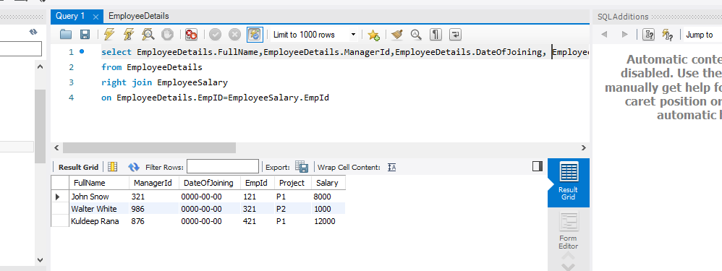

**Now take these two tables:**

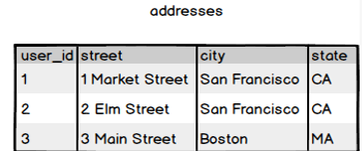

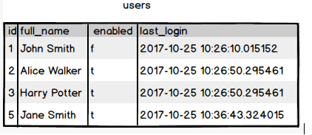

**Ques.11. Write a SQL query to fetch all users full_name from San Francisco.**

**Answer:**

**1.select Users.ID, Users.Full_name, Adresses.city**

**2.from Users**

**3.right join Adresses**

**4.on Adresses.UserId=Users.ID**

**5.where Adresses.City='San Francisco'**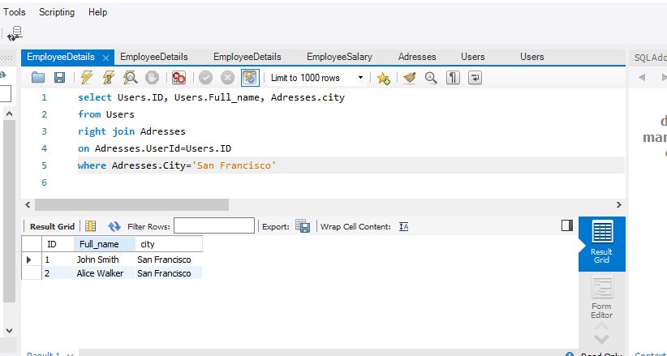

**Ques.12. Write a SQL query to fetch all users full_name, last_login who are enabled**

**Answer:**

**1.select Users.Full_name, Users.last_login**

**2.from Users**

**3.where enabled='t'**

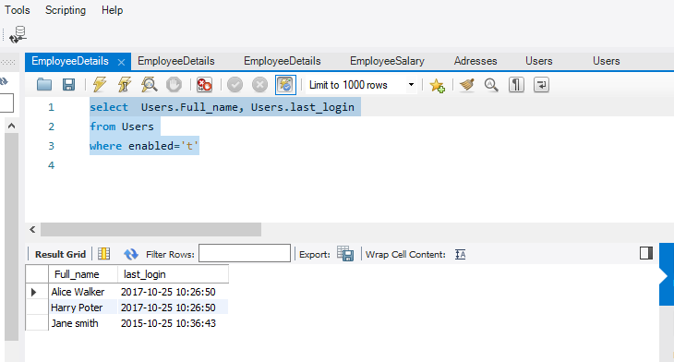

**Ques.13. Write a SQL query to fetch all users full_name who are not from Main street**

**Answer:**

**1.select Users.ID, Users.Full_name, Adresses.street**

**2.from Users**

**3.Inner join Adresses**

**4.on Adresses.UserId=Users.ID**

**5.where not Adresses.street= '3Main Street'**

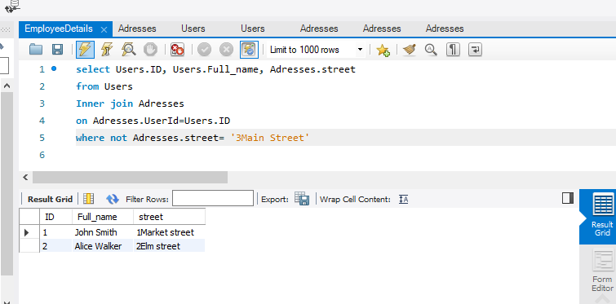

**Ques.14. Write a SQL query to fetch all users full_name who are from Main**

**Answer:**

1.select Users.ID, Users.Full_name, Adresses.street, Adresses.City

2.from Users

3.Inner join Adresses

4.on Adresses.UserId=Users.ID

5.where Adresses.street= '3Main Street' or Adresses.City='San Francisco'

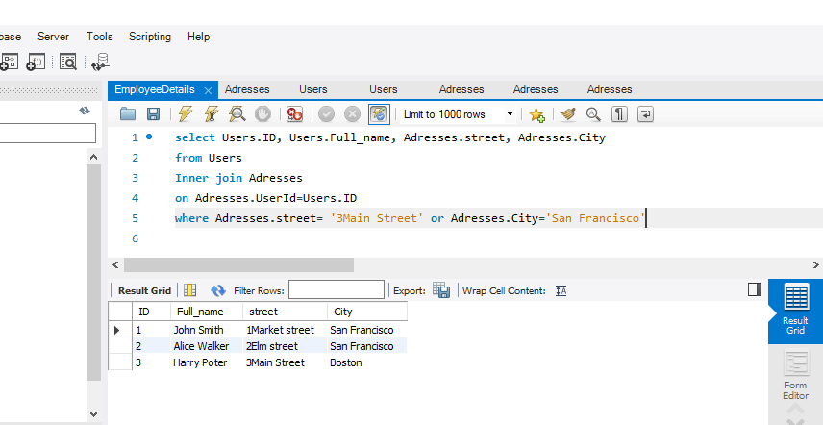

**Ques.15. Write a SQL query to fetch user full_name who is equal to user_id from Boston (find user_id value in sub_query)**

**Answer:**

1. **Select * from users**
2. **Where Users.Id =‘Boston’**

**(select user Id**

**From addresses**

**Where user Id=Boston);**